Hand Washing System for Preventing Covid-19

Amit Roy#1, Sadia Shahreen#2, Shekhor Chandra Saha#3

Computer Science and Engineering, East West University,  
Jahurul Islam City Gate, A/2 Jahurul Islam Ave, Dhaka 1212, Bangladesh

[12017-3-60-021@std.ewubd.edu](mailto:12017-3-60-021@std.ewubd.edu)

[22017-1-60-071@std.ewubd.edu](mailto:22017-1-60-071@std.ewubd.edu)

[32017-3-60-025@std.ewubd.edu](mailto:32017-3-60-025@std.ewubd.edu)

Abstract— COVID pandemic has influenced human life in various sectors. Various attempts were made to reduce the virus transferring by work from home, social distancing, and also including hand hygiene. So far, most of the available hand sanitizers do not operate automatically [1]. This project aims to make an automatic hand washing system where soap and water can come out automatically. This project presents the overall design of "Automated Hand Washing System for Preventing Covid-19" with low-cost and. Hand washing is a critical activity in preventing the spread of infection in health-care environments and food preparation areas. This system is designed to assist and provide support in order to fulfil the needs of elderly and prevention of Covid-19 [2]. Also, the smart hand washing concept in the system improves the standard. The sensor mode is used to control the liquid soap and water supply. So that we can wash hand without any touch and maintain the necessary timing.

Keywords— Arduino Uno, Relay, IR Proximity Sensor, Servo, Submersible Pump, Covid-19.

1. Introduction

The Weekly Epidemiological Update provides an overview of the global, regional and country-level COVID-19 cases and deaths, highlighting key data and trends; as well as other pertinent epidemiological information concerning the COVID-19 pandemic [3]. The COVID-19 pandemic in Bangladesh is part of the worldwide pandemic of coronavirus disease 2019 (COVID-19) caused by severe acute respiratory syndrome coronavirus 2 (SARS-CoV-2). The virus was confirmed to have spread to Bangladesh in March 2020 [4]. As the recommendation of WHO, we know the only effective way for preventing Covid-19 is "hand-washing". Repeatedly hand washing can stop affect people by Covid-19. But there is another problem of cause of infecting by Covid-19 is "touch". It has become most risky

So that, we tried to find a solution for washing hand without touch anything. Thereby, we may prevent the convolution of this disease.

1. Related Works

There are many projects we have watched before which did provide automated hand wash system. There the system provided only the soap in an automated formula for hand washing. Normally there is a bottle of liquid soap which supply liquid soap and then people wash out with water which is supplied from any manually controlled tap. Nowadays people around the world are so much concern about Covid-19, it creates a pandemic situation over the world. World Health Organisation declared a statement about the way of preventing Covid-19. They said "Hand hygiene is the single most effective action, you can take to reduce the spread of pathogens and prevent infections, including the Covid-19 virus". By this statement we can assure that washing hand can play a vital role for preventing Covid-19.

We also know that Covid is a contagious disease that is why touch everything become a sensitive issue. Disease can transfer one to another by a simple touch. Washing hand is one of the vital reasons of this. So that we tried to work with a project which is " Automated Hand Washing System for Preventing Covid-19 ". Here we tried to make system where we don’t have to touch anything with hand. This will give liquid soap by the help of sensor and for washing hand, water supply also by the help of sensor. We tried to maintain the timing. 20 seconds is the safe time for rubbing hand with soap if we want to prevent Covid-19. The system will supply water in necessary amount so that there will be no loss. Without touching anything we can wash hand with maintaining the necessary time limit, it definitely can help for preventing Covid-19 without any risk and without touching anything, timing are the advance steps for out project that don't happen before.

1. proposed work

In this project, we will try to implement the automated hand washing system. Now-a-days, World is going towards a bad situation due to Coronavirus. World Health Organization (WHO) advised us to wash our hand frequently. So, we decided to implement this system. In this system, there is a handwash which works automatically and also supply water automatically

First of all, we have to take our hand under the water tap then fall out water automatically for few seconds. Then we have to move our hand Infront of the handwash and fall out the sufficient soap automatically and rub our hand for 20 seconds. After 20 seconds we have moved our hand under the water tap so that the hand wash properly with sufficient water.

We will also try to add some extra features like we can exclusion of wasting water, without touching anything anyone can wash their hand, we will ensure hand washing for at least 20 seconds. Because WHO advised us to wash our hand at least 20 seconds.

There are no chance to infect others because this system works without touching.

1. DESCRIPTION

In this project we use some devices or modules. For programming we use Arduino uno. We use servo motor for giving liquid soap automatically. For suppling water, we use 5V submersible pump and use a 5V relay for controlling it.

**ARDUINO UNO:**

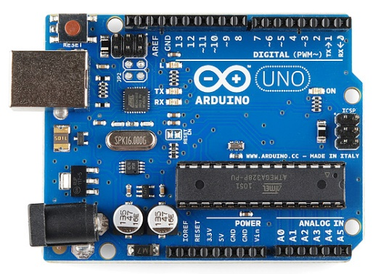

Figure 1: Arduino Uno

ANALOG INPUT:

Arduino uno board consist of 6 analog input pins. These analog inputs are named from A0 to A5. Using analog inputs, we can do the overall process. Analog inputs can be used in the operating range of 0 to 5 V. It is considered as the continuous time signal. For certain application, these analog time signals can be used. These are also called as non-discrete time signal. There are inputs like voltage, current etc. are considered as analog signal or digital signal and these are considered by analysing that time signal properties. Various applications od Arduino Uno can be used as only an analog input instead of digital inputs. For these applications analog input ports or pins can be used.

DIGITAL INPUT:

With discrete input pulses digital inputs can be defined as the non-continuous time signal. As 0’s and 1’s it can be represented. Either on state or in off state these digital inputs can be. 12 digital input pins include Arduino Uno. D0 to D11. I can be started. Mainly 12 inputs can be used for this application. Where the discrete input pulses can be triggered and supplied to the ports then the digital inputs working. These ports receive the input and can be used input and output both processes. In digital inputs only digital pins are accessible.

POWER JACK CABLE / USB PORT:

This Arduino Uno can be interfaced with the other electronic devices such as computer by using USB port or power jack cable from these power jack cable, we can upload the program of Arduino for their applications. At first, the program can be initialised or can be edited by using Arduino software tools. Then these programs can be transferred through Arduino microcontroller board by using USB cable or power jack cable.

POWER SUPPLY:

****There is an additional power supply source situated in Arduino uno. Power supply port is situated at the corner of the Arduino Uno. We can use power supply port in two ways. One is, connecting with external power supply or another way is by connecting an dc power supply through input pins. These kind of power supplies produce an active form to the Arduino uno and this can accept a range of power supply when the power supply voltage range exceeds. Then the Arduino uno gets damaged. Therefore, only the particular range of power supply should be given to the Arduino uno [5].

**IR PROXIMITY SENSOR:**

Figure 2: IR Proximity Sensor

POWER SUPPLY:

Power supply can be used from Arduino uno board or external power supply. Which must be 5v. In IR Proximity Sensor board there are 3pins. These are VCC, GND and Output. VCC and GND are for connecting with power supply. If we use power supply from Arduino uno board then VCC connected with the VCC of Arduino uno board and ground also same as VCC.

OUTPUT:

If there any obstacles come near the IR sensor, an output generates from the IR Proximity sensor and this output will work as an input of Arduino uno. Which pin number is 3 [6].

**SERVO MOTOR:**

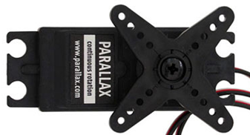

Figure 3: Servo Motor

POWER SUPPLY:

Power supply can be used from Arduino uno board or external power supply. Which must be 5v. In IR Proximity Sensor board there are 3pins. These are VCC, GND and IN. VCC and GND are for connecting with power supply. If we use power supply from Arduino uno board then VCC connected with the VCC of Arduino uno board and ground also same as VCC.

INPUT:

To control the servo there is an input connection with Arduino uno. Which is connected with pin number 10. This is an analog pin and control the rotation of servo [7].

**RELAY MODULE:**

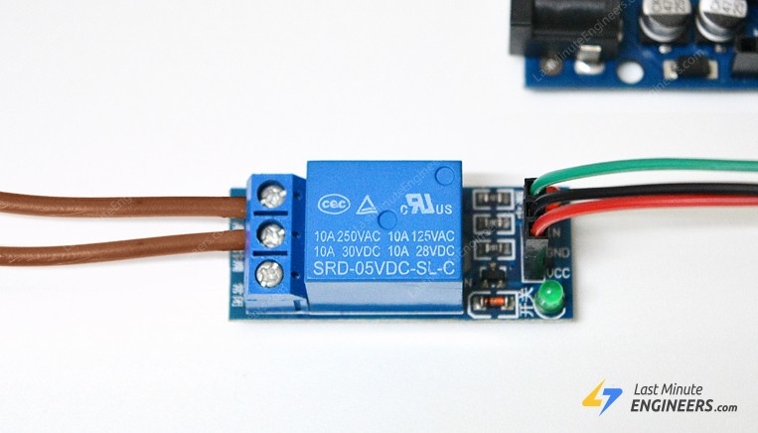

Figure 4: Relay Module

POWER SUPPLY:

Power supply can be used from Arduino uno board or external power supply. Which must be 5v. In IR Proximity Sensor board there are 3pins. These are VCC, GND and Output. VCC and GND are for connecting with power supply. If we use power supply from Arduino uno board then VCC connected with the VCC of Arduino uno board and ground also same as VCC.

INPUT:

To control the relay module there is an input connection with Arduino uno. Which is connected with pin number 8. This is a digital pin and work like as switch [8].

.

**SUBMERSIBLE PUMP:**

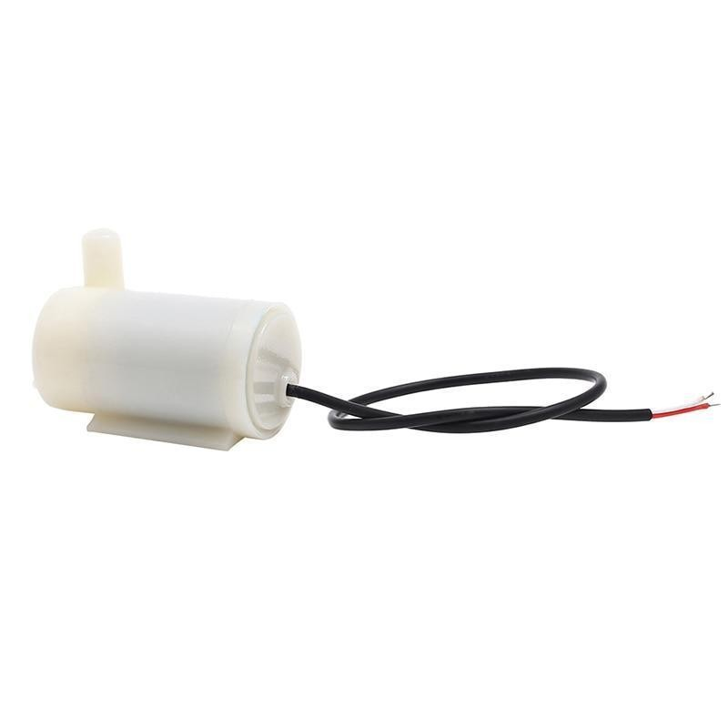

Figure 5: Submersible Pump

POWER SUPPLY:

Need external power supply. Since we use 5v submersible pump, we need 5v extra power supply.

1. WORKING PRINCIPLE

PROCEDURE:

In this project we use Arduino uno, IR Proximity Sensor, Servo motor, 5V Relay and a Submersible Pump. We use IR Proximity Sensor for generate an output signal. it is connected with Arduino uno in pin number 3. By pin number 3, Arduino uno receive input from IR Proximity Sensor. We use a servo motor for control liquid soap by connecting with Arduino uno pin number 10. Pin number 8 is connected with a 5V Relay Module and this module control a submersible pump which is supplying water for hand wash.

In figure 6 the connection pins are given in the diagram.

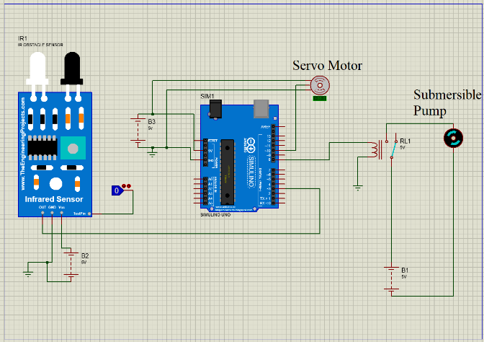

Figure 6: Arduino Uno

PROGRAM:

#include <Servo.h>

Servo servo1;

int relayPin = 8;// define output pin for relay

int irinput = 3;

void setup() {

pinMode(relayPin, OUTPUT);// define pin 8 as output

pinMode(irinput,INPUT);

servo1.attach(10);

}

void loop() {

if (digitalRead(irinput)== LOW)

{

digitalWrite(relayPin, LOW); // turn the relay ON (low is

ON if relay is LOW trigger. change it to HIGH if you have

got HIGH trigger relay)

delay(5000); // wait for 500 millisecond

digitalWrite(relayPin, HIGH);

delay(1000);

servo1.write(180);

delay(1000);

servo1.write(0);

delay(6000);

servo1.write(180);

delay(1000);

digitalWrite(relayPin, HIGH);

delay(20000);

digitalWrite(relayPin, LOW);

delay(10000);

digitalWrite(relayPin, HIGH);

delay(1000);

}

else

{

digitalWrite(relayPin, HIGH);// // turn the relay OFF

(HIGH is OFF if relay is LOW trigger. change it to LOW if

you have got HIGH trigger relay)

}

}

1. Experimental result

Though this project is for preventing covid’19. This project helps us to decrease the rate of patients. Hardware project is given below:

Figure 7: IR sensor and Submersible Pump

Figure 8: Soap Battle and Servo Motor

Figure 9: Project from front View

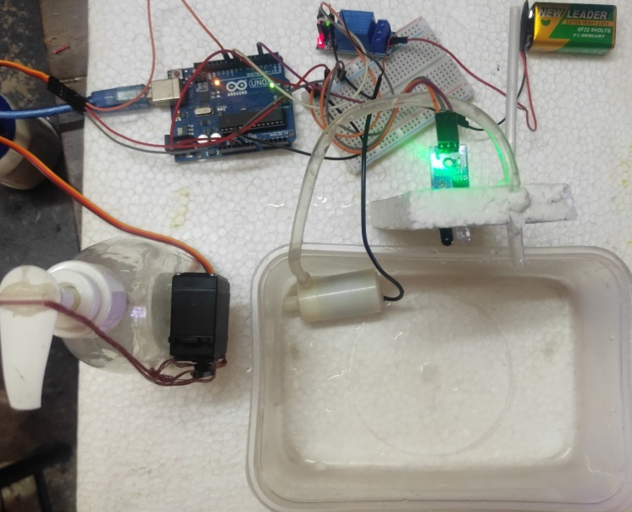

Figure 10: Project from top View

In this project first we need to get some water and for this we must give our hand Infront of the IR sensor. Then give hand in front of the soap battle. Then after 20secondss again gives us water for hand wash.

For this project if we rapidly use this then corona virous can be prevent. WHO said that it is very necessary to clean our hand every 30 minutes and it is very working process. If we follow the instruction of WHO then we will be safe.

1. Future scope

We made this project how much we can manage to do. But there is some more to do that is we cannot implement right now though we have some thought about the future establishment of this automated hand washing project. As a novel application, the results appeared in this commitment are empowering results for a multi-class arrangement issue with seven classes. Be that as it may, a few assignments are anticipated the future to both improve the exhibition and lessen the calculation costs. The hunt of an ideal compromise between the segregation force of the component vector and its size is a significant issue to lessen the general calculation load in on-line frameworks. Single casing grouping can be improved by adding a multi-outline approval measure, in which stochastic models (covered up Markov models, for example) may assume a significant part incorporating arrangement data. New informational indexes will be made for preparing and test, under different lighting conditions, with various sorts of sinks and a bigger assortment of subjects, trying to improve the strength and the speculation capacity of the proposed framework. At long last, albeit the multi-class SVM group seems to yield great arrangement results, the utilization of different options with a lower computational expense are in our degree, anticipating incorporate this application into a plausible minimal expense FPGA stage to effectively manage the improvement of minimal expense remote sensors to quantify human action. Every one of these issues are important for our ebb and flow lines of exploration and will be concentrated exhaustively in future commitments. Maybe improvement ought to zeroed in on advancing the equipment, lodging and electrical source. expansion of dryer ought to likewise be intended to satisfy the hand washing guideline that incorporates drying action.

1. Conclusions

The utilization of new electronic speculations has been put somewhere near skill to expand the offices given by the current machine. Here the office of conventional hand washing is expanded by the making it controlled consequently. Programmed hand washing gives medical advantages and programmed application. This framework is easy to utilize and proficient. It is amassed effortlessly. It is modest and subsequently exceptionally monetary. It is little in size and is fixing inside ordinary bowl. Eventually, this framework is broadly utilized in better places like public or individual. And afterward, programmed hand washer is made in low financial plan. This machine has been tried under numerous conditions and has given a palatable outcome and has end up being productive. Before developing programmed hand washer, the main significant thing is to pick the correct parts list. It is additionally expected to consider the information sheet of these segments. It is tried on widespread undertaking board. A completely programmed spigot for hand washing has been created utilizing Interaction Design cycle to augment its ease of use. The examination on reification, libation and User participation test has shown that it capacities well to constrain clients to utilize cleanser in their hand washing routine and to scour in 2 seconds just as dominate the convenience as far as Usefulness, satisfaction and easiness. Farther advancement ought to zeroed in on optimizing the equipment, lodging and electrical source. In Covid situation, this system is so important and lifesaving. As we all know than, Covid is a contagious disease. That is why without touching formula plays an important role here and people need this for surviving this pandemic.

Acknowledgment

We would like to express our special thanks of gratitude to our course instructor professor Nawab Yousuf Ali who has given us the golden opportunity to do such useful project on the topic handwashing system for preventing covid’19, which also helped us to doing a lot of research and we came to know about so many new things we are really thankful to our course instructor.

Secondly, we would also like to our friends and group mates who helped us a lot in finalizing this project within the limited time frame.

References

[1] “Atlantis Press | Atlantis Press Open Access Publisher Scientific Technical Medical Proceedings Journals Books.” https://www.atlantis-press.com/ (accessed May 10, 2021).

[2] D. F. Llorca, I. Parra, M. Á. Sotelo, and G. Lacey, “A vision-based system for automatic hand washing quality assessment,” *Machine Vision and Applications*, vol. 22, no. 2, pp. 219–234, 2011, doi: 10.1007/s00138-009-0234-7.

[3] “Coronavirus disease (COVID-19) Weekly Epidemiological Update and Weekly Operational Update,” *WHO*, 2021. https://www.who.int/emergencies/diseases/novel-coronavirus-2019/situation-reports.

[4] “COVID-19 pandemic in Bangladesh,” *Wikipedia*, 2021. https://en.m.wikipedia.org/wiki/COVID-19_pandemic_in_Bangladesh.

[5] “Arduino UNO for beginners - Projects, Programming and Parts,” *makerspaces.com*, Accessed: May 10, 2021. [Online]. Available: https://www.makerspaces.com/arduino-uno-tutorial-beginners/.

[6] “Proximity sensor - Wikipedia.” https://en.wikipedia.org/wiki/Proximity_sensor (accessed May 10, 2021).

[7] “Servomotor - Wikipedia.” https://en.wikipedia.org/wiki/Servomotor (accessed May 10, 2021).

[8] “Relay - Wikipedia.” https://en.wikipedia.org/wiki/Relay (accessed May 10, 2021).